BLOODHOUND face MAsKS - $5.35

COTTON MASK WITH AROUND THE HEAD ELASTIC STRAPS
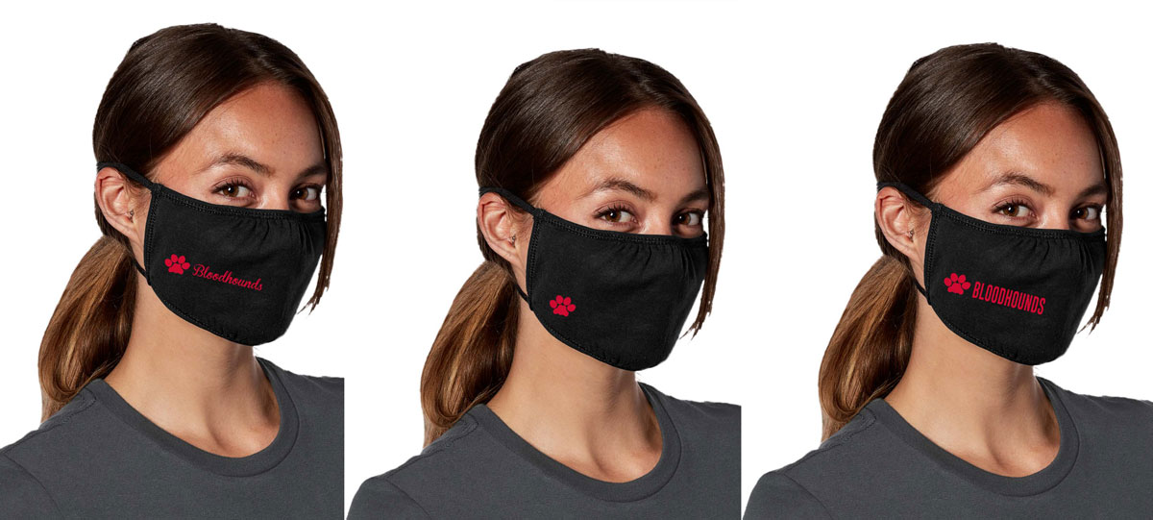

STYLE 1 STYLE 2 STYLE 3
$5.35 Per Mask. This Cotton Face Mask has a shaped fit with an adjustable piece around the nose. The elastic head straps go around the head rather than ear loops. Youth sizes are available upon request but are only available with the ear loops. While supplies last. Pricing subject to change
- 3-ply 100% combed ring spun cotton
- Machine washable
- Gathers at nose and chin
- Non-medical use only
- Non-returnable

STYLE QUANTITY SIZE

(Adult or Youth)
STYLE 1
STYLE 2
STYLE 3

TOTAL

For office use only: (Form of payment & date)

